Kids Food System:

- What is the food system?

  - The food system is the path that food takes to get from the farm to our table.

  - There are 5 steps to the food system. Each requires its own energy inputs.
    - Producing or growing food (Production)
      - Energy input (example: water and fertilizers for crops and food for cows and other animals that we get food from).

    - Processing and packaging food (Processing)
      - Energy input (example: power for the factory that processes our food, water for washing our food, materials for packaging our food).

    - Transporting food to the store (Transportation)
      - Energy input (example: gas for driving or flying food to the store).

    - Buying and eating food (Consumption)
      - Energy input (example: gas for driving our cars to the store, energy for cooking food, refrigerators for keeping food fresh).
    - Waste
      - Waste can occur at any point in the food system! What are ways it can occur at each step?
      - Examples: Crop waste, packaging waste, food spoilage during transport, letting food go bad before it’s eaten.
      - Overall, about 1/3 of the food that is grown never makes it to the consumer. That’s a lot of waste!

- Where does our food come from?

  - Food can come from all over the world
    - Sometimes it’s grown in a farm outside of town
    - Sometimes it’s grown on the other side of the world.

  - The distance your food travels from where it’s grown to you is called its “food miles”
    - So…America doesn’t have the right climate for growing bananas, we get most of them from Central America. These travel about 4000 miles to get to us!
    - Or...Food grown by a local farmer, such as potatoes or tomatoes, travels much less – usually less than 25 miles – to get to us

  - When food travels less distance, it uses much less energy (gas) and is often much fresher and tastier!

- Why should we care about where our food comes from?

  - Where and how our food is grown can make a huge difference on the amount of energy it uses to get to us and the impact it has on the environment.
  - In order to conserve natural resources, lessen pollution from transporting food, and ensure that everyone has something to eat, we should try to be more conscious of what we’re buying.
    - There are millions of people around the world that don’t get enough food. If we do better to ensure there’s less food waste, we can better ensure that more people have healthy and tasty meals.

- How can you lessen your food impact?

  - Follow this buying tip (or inform whoever buys food in your house)
    - First, buy in season.
      - Food that is “in season” is food that naturally grows at that time of the year. This means less energy needs to be input in order to grow it.

    - Second, buy local
      - Local food is being grown right in our own towns. If we buy local food, it doesn’t have to travel as far, reducing the environmental impacts of transporting it.

    - Third, buy organic
      - Buying organic is usually a bit more expensive. However buying organic means that the practices the farmers use are less harmful to the environment, and to ourselves. It’s better for everyone!
  - Eat less meat
    - Meat takes a lot more energy to produce than food from plants like fruits and vegetables. Replacing one dinner a week with a meatless option is a great way to cut down energy impacts of your food.

  - Eat less processed food
    - This is things like chips, cookies, crackers and so on.
    - Usually, the more packaging a food has, the more processed it is. Processing food take a lot more energy than raw foods like fruit or veggies.

  - Make sure food is eaten before it goes bad!

  - Try growing your own food

Questions:

  - You have the option to buy a tomato from location A, where it is in season, or Location B where it is not in season. Which tomato requires less energy to be grown?
    - Location A
    - Location B
    - They are the same

  - What is a food mile?
    - The number of apples, lined up end to end, to measure a mile
    - The distance your food must run in P.E. class
    - The distance your food travels from where it’s grown to get to you
    - How fast your food gets to you

  - Which of the following uses less overall energy and has less environmental impact?
    - An apple grown 1000 miles away from the store
    - An apple grown 50 miles away from the store

  - Which of the following is NOT a processed food?

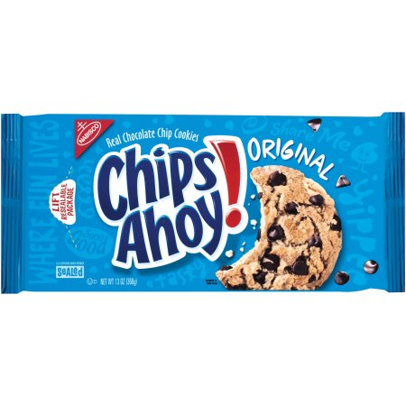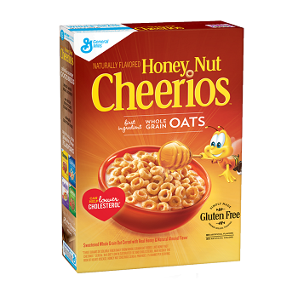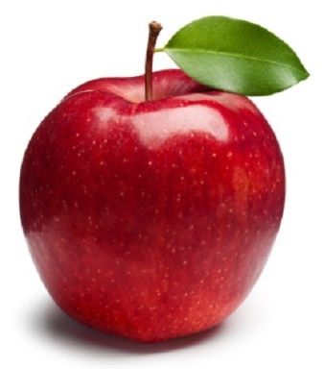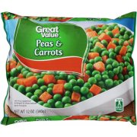

  - Which of the following is a way you reduce your food energy impact?
    - Eat less meat
    - Eat less processed food
    - Buy in season, local, and organic food
    - Grow your own food
    - All of these are great!

